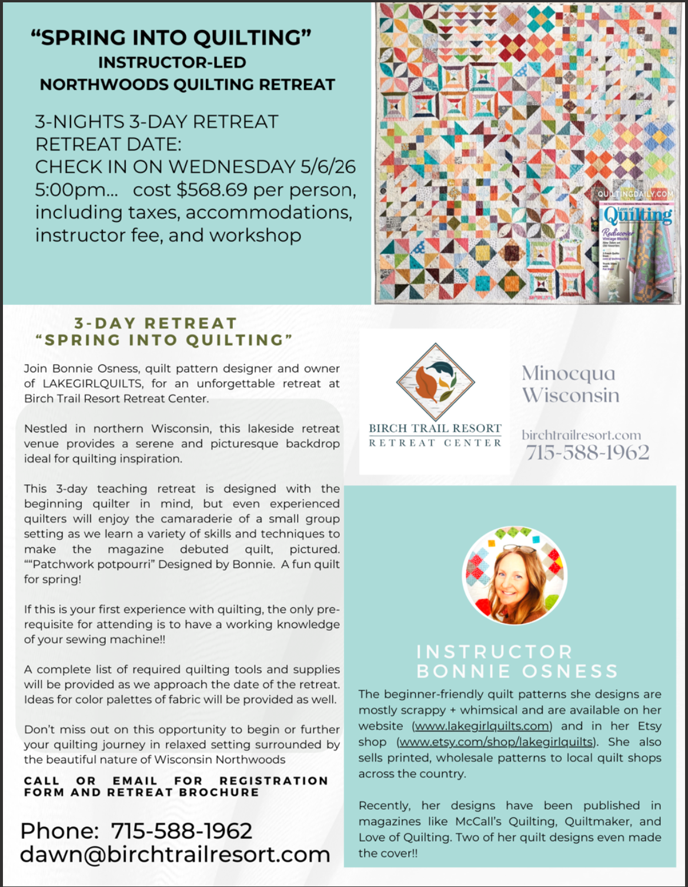
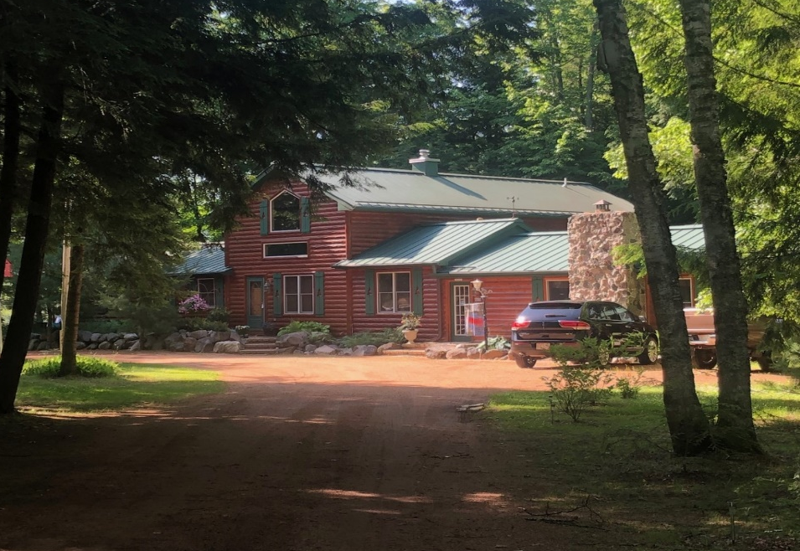

Spring Into Quilting – with Bonnie Osness – Instructor Led Northwoods Retreat
Spring 2026 - Retreat Dates:
- Wednesday 5/6/26 check – in and start of retreat; Saturday by 12:00noon conclude, check out

Note: You all will have beautiful lakefront cabins for sleeping accommodation. Gorgeous workshop with windows surrounded by a natural Northwoods setting for your instruction setting each day.
Cabins all have fully equipped kitchens, living room, separate bedrooms, outside decks with full view of lake.
Names of attendees will be shared so that you can all coordinate a “potluck” of snacks for each day and shared. Meals not included in package.

)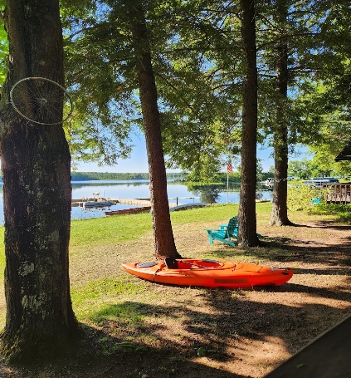 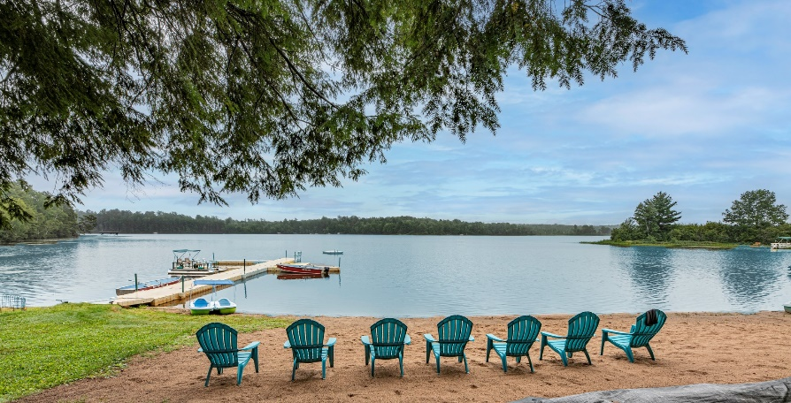
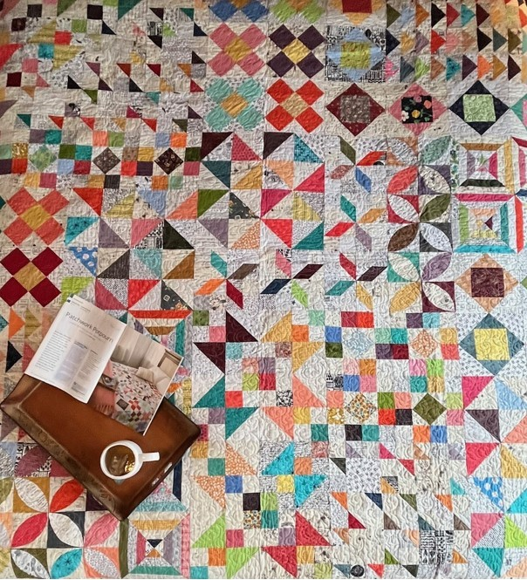

RETREAT ITINERARY

Wednesday– Arrival at the resort by 5:00pm. Cabins available and check in at 3:00pm

Attendees may unload all equipment, materials and supplies in the quilting workshop. Register for your cabin with Dawn at the main lodge office.

5:00PM - Meet and greet along with a wonderful trunk show with Bonnie Osness. Housekeeping notes – Dawn Plankey, owner operator of resort. And a start to quilting instruction.

Thursday
Morning – you will each have breakfast in your cabins (you may plan meals together or bring your food items separately.)
Instructor begins class at 8:30am – have all of your sewing machines, materials and supplies ready for start of class.
Lunch – all on your own to return to your cabin for lunch – you may plan together or separately.
Afternoon instruction continues until 5:00pm
Each attendee may continue to work in the workshop up until 10:00pm the workshop will be open.
Dinner – typically all attendees coordinate making food items to all have dinner together in one of the cabins, rotating cabins each night.

Friday
Morning – breakfast in your cabins
Instructor begins class at 8:30am
Lunch on your own in your cabins
Afternoon class instruction until 5:00pm
Workshop open until 10:00pm

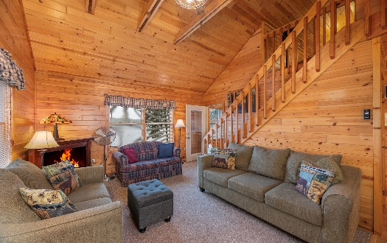
Saturday
Morning – breakfast in your cabins
Instructor begins class at 8:30am
Lunch on your own in your cabins
Retreat ends 11:00 a.m.

Supply List: Provided upon registration, all instructions for supplies and fabrics, etc. needed to sew this quilt.

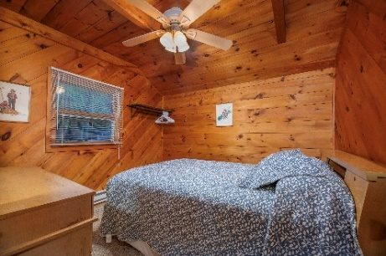
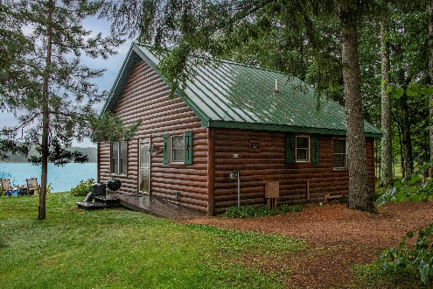

Accommodation Details and What to Bring
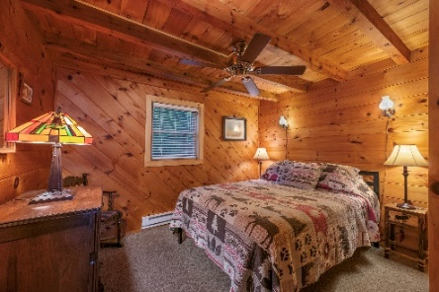
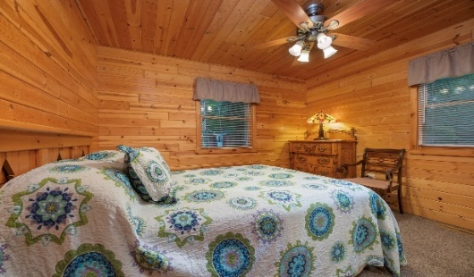
Each cabin can accommodate 3—4 ladies -if you have a group of gals attending together you can all be in one cabin, otherwise roommates will be assigned. Your cabin is immaculately clean with comfortable mattresses, fresh linens, double protected pillows, fully equipped kitchen with full refrigerator, stove, microwave. Cabins that are dedicated to this workshop – “The Minnow”, “White Pine”, “Loon Loft” and “White Tail” (more details with pictures and bed configuration can be found on our website: birchtrailresort.com ). You will bring your bath towels, bathroom toiletry items, food for breakfast, lunch and dinner, any extra garbage bags, papertowels, paperplates and napkins for workshop snacks.
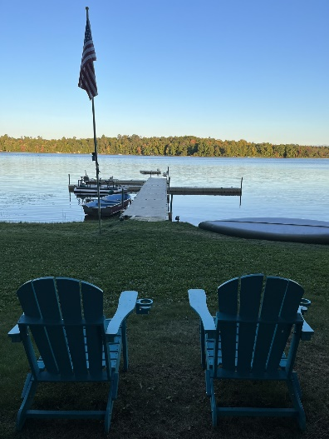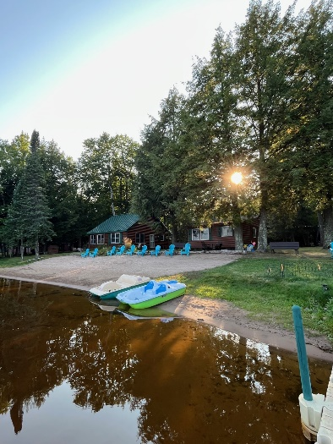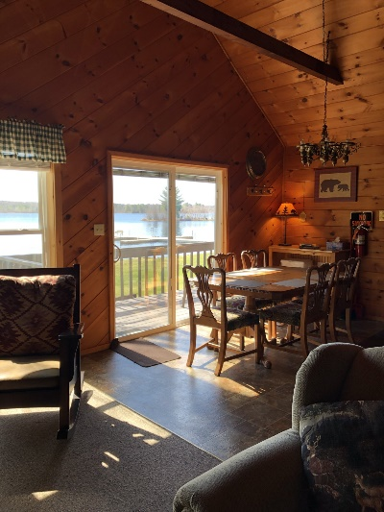

Workshop Retreat Per Person Pricing:
Three nights three days, instructor lead classes (see program details above), sharing accommodations in 1 of our 4 cabins (see details on cabins above and in description of classes) See website for more pictures and details: birchtrailresort.com
Cabin 3 – White Pine – 3 bedrooms – 3 roommates.
Cabin 1 –The Minnow- three roommates; two large bedrooms main level and one large loft.
Cabin 4 – White Tail -three roommates total; two bedrooms main level and one large loft.
Cabin 5- Loon Loft – three roommates; two bedrooms main level and one large loft.
$568.69 includes occupancy and sales tax per person, (with roommates as listed above)
Deposit: $355.00 due at time of reservation. Remaining balance due in cash at resort check-in
Cancellation Policy: Deposit will be retained for any cancellation. Registrant is able to transfer their reservation to another to avoid losing deposit.

Workshop has overhead and task station lighting with no florescent bulbs, one wide ironing board, large cutting table, 8foot and 6 foot work tables, surge protector extension cords at each station, comfortable task chairs, side accessory tables, full refrigerator, area for snacks, restroom.

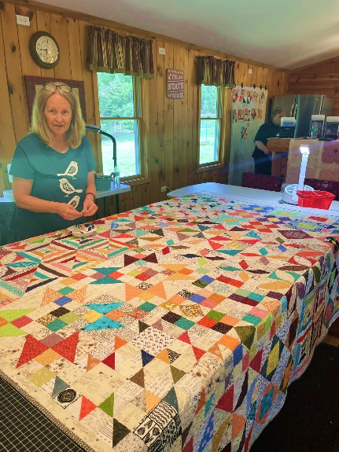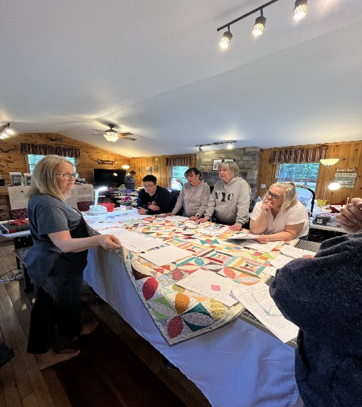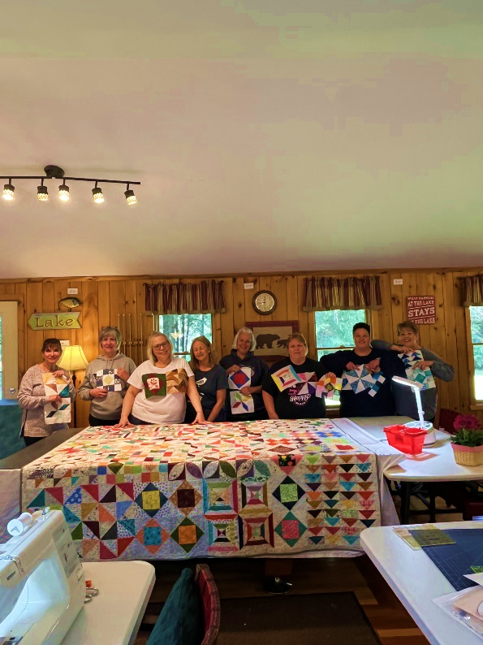

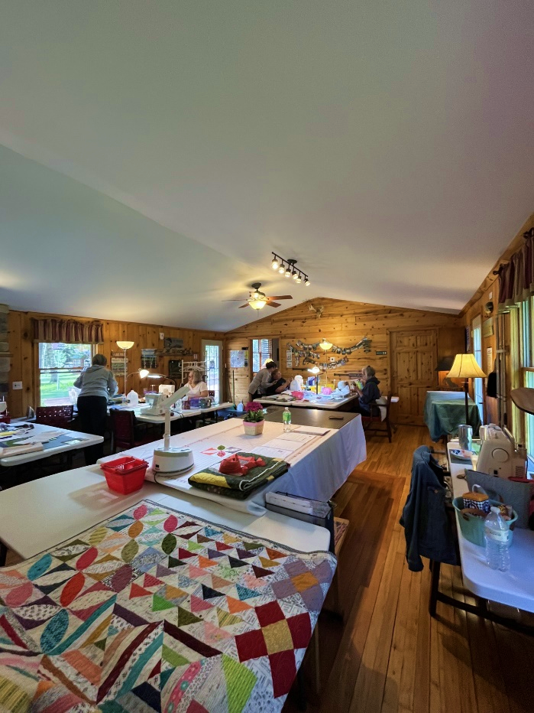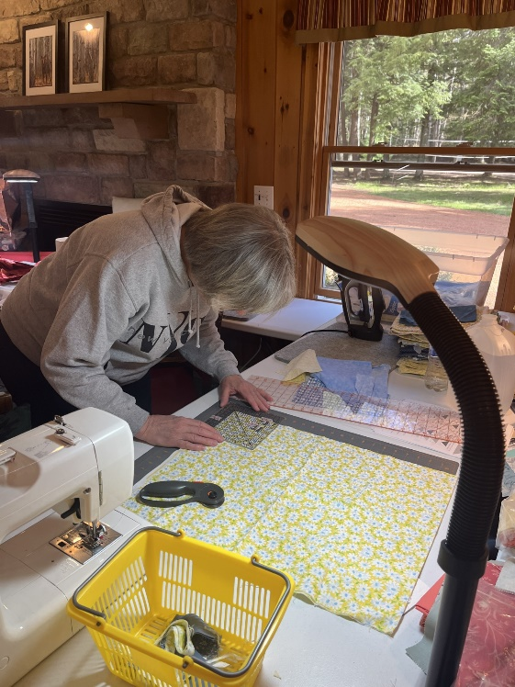

REGISTRATION FORM
Everyone is welcome, all you need is sewing machine experience for the introduction class – come with a group or by yourself.

“Spring into Quilting” 3-day Retreat - A Weekend for fun, community, creating, meeting new people, and learning in an incredible Northwoods location.

Dress is casual all weekend, bring a sweater for the workshop and boots just in case we have chilly weather.

Once we receive your deposit, supply lists will be sent over so you know exactly what to be collecting/buying/borrowing before the retreat.
We will also share your email and name so that you can coordinate a pot luck dinner and snack option with all attendees if you like.
A $355 registration fee holds your spot/Balance due at the time of the retreat- cash or PayPal (3% fee) only at check in.
(If you cancel the weekend deposit is non-refundable, however transferable to someone for same dates)
(Cancellation four weeks or less before the event, registration fee will not be returned)

Send registration fee, or work with Dawn Plankey (owner, retreat coordinator) for a Paypal option, made out to Birch Trail Resort

Birch Trail Resort Retreat Center 8820 W. Amber Lake Road , Lac du Flambeau WI 54538
The Resort is located in Minocqua, post office is in Lac du Flambeau

For questions or more information contact Dawn Plankey – Dawn@birchtrailresort.com cell: 847-989-2587 Office: 715-588-1962


Please print clearly!

Name:______________________________________________________Email:____________________

Address:________________________________________________________________

_________________________________________________________Zip:________________________

Phone Home:____________________Work:_____________________Cell:_____________________

I would be interested in car pooling from _______ I would be driving and will take passengers
- I will be rooming with __________________ and _________________________ and ____________________________ (if you already have room mates, if not we will assign), let us know which cabin is your favorite and then second choice, we will try to assign everyone to their favorite if possible. Cabin _________________________________________
Dates I am confirming _____May 6, 2026
- I approve having my email and name shared with other attendees to coordinate snacks and meals

Deposit:__________Check No.__________ or call Dawn for PayPal

